Kaurna Artist Expression of Interest

Adelaide Visitor Experience Centre (AVEC) Project

An exciting opportunity for Kaurna artists

Closing Wednesday, 27 May 2026
Yanun, on behalf of the City of Adelaide and Adelaide Economic Development Agency (AEDA), is seeking expressions of interest from Kaurna artists to contribute to the Adelaide Visitor Experience Centre (AVEC), a new immersive, digital destination to be located within the State Library of South Australia.

This project is an opportunity to create a highly visible public artwork that will form part of a dynamic storytelling experience, connecting visitors to Kaurna Country and surrounds, through contemporary cultural expression.

About the project
The AVEC is the modern evolution of visitor engagement - transitioning from a traditional information centre into a world-class, immersive digital environment. The new centre will use smart technology and large-scale projections to invite visitors to discover Adelaide’s stories, landscapes, and experiences.
At its heart is a commitment to embedding Kaurna cultural narratives, ensuring visitors experience the depth, continuity and living presence of Kaurna Country.

The opportunity
We are seeking a Kaurna artist/s to create original artwork/s, to be integrated into immersive projection and interactive environments within the new AVEC (see visual references below).
This may include:
- Large-scale visual artwork adapted for projection on an immersive environment
- Artwork integrated into spatial experiences such as floor projection
- Soundscape elements such as music
The selected artist will collaborate with a multidisciplinary team including designers, digital specialists, and project stakeholders.

Creative direction
We are looking for work that:
- Reflects Kaurna Country, environment, and cultural narratives and storytelling
- Is visually engaging and contemporary
- Can translate into immersive digital formats
- Relates to the client’s brand
Artist/s will be supported by the project design team, who will provide technical specifications and guide integration into the broader experience. The work may be delivered as a high-resolution digital artwork (preferable), or a physical work such as painting, no smaller than 1200mmx1200mm (which can be digitised by the design team). The soundscape may be delivered as digital audio files.

Commission packages (indicative)
Artist/s may nominate for one or more of the following bodies of work:
Item | Description | Proposed Fee Ex GST
Floor Projection Artwork | Artwork adapted for large-scale floor projection | $3,000
Mirrored Tunnel Artwork | Original signature artwork adapted for interactivity within a key immersive space (wall and floor projection) | $15,000
Soundscape Contribution | Audio or atmospheric elements | $3,000
(Artist/s may choose to be considered for one or more of the items listed above, or propose alternatives or expanded scope as part of their submission.)

Licensing
The City of Adelaide will license the commissioned artwork for use within the AVEC and associated promotion for a period which may extend up to 10 years.
This includes:
- Use within the AVEC installation
- Marketing and promotional materials
- Digital and print applications related to the centre.
Artists retain authorship and will be credited.
A full agreement will be developed with the selected artist.

What’s involved
The selected artist/s will:
- Collaborate with client, designers and technical teams
- Participate in a briefing, creative workshops and regular review sessions (i.e. weekly/fortnightly)
- Contribute to documentation and storytelling of the project (this includes capturing the development of the works)
- Develop original artwork for the project
This is a collaborative, co-design process with opportunities for creative input and cultural leadership.

Key dates
- EOI closes: Friday, 27 May 2026 at 5:00PM ACST
- Panel selection period: 2 weeks
- Briefing, initiation and concept approval: June 2026
- Production of final digital or physical artwork and/or soundscape elements: June – Mid-July 2026
- Technical integration and digital application of final artwork and/or soundscape elements: July 2026

How to apply
Please provide the following information to the below contact details by the closing date:
Email: info@yanun.com.au
Subject: AVEC Artist Submission – [Your Name]
Artist Details
- Name:
- Email:
- Phone:
Cultural Identification
☐ I identify as Aboriginal and/or Torres Strait Islander (please specify language group/s):
Artist Biography (max 150 words)
Scope Item (Artist would like to be considered for which scope item)
☐ Floor Projection Artwork
☐ Mirrored Tunnel Artwork
☐ Soundscape Contribution
☐ Other, please specify:
Portfolio (Provide up to 6 images or links, with examples of previous works)
Statement of your approach to place and cultural storytelling (max 250 words)

Contact
Should you have any queries please reach out via email to info@yanun.com.au with luke.panayiaris@yanun.com.au cc’d.

Image References

Example of large-scale visual artwork adapted for projection on an immersive environment (Proliferating Immense Life, teamLab, 2020, Interactive Digital Installation, Sound: Hideaki Takahash)
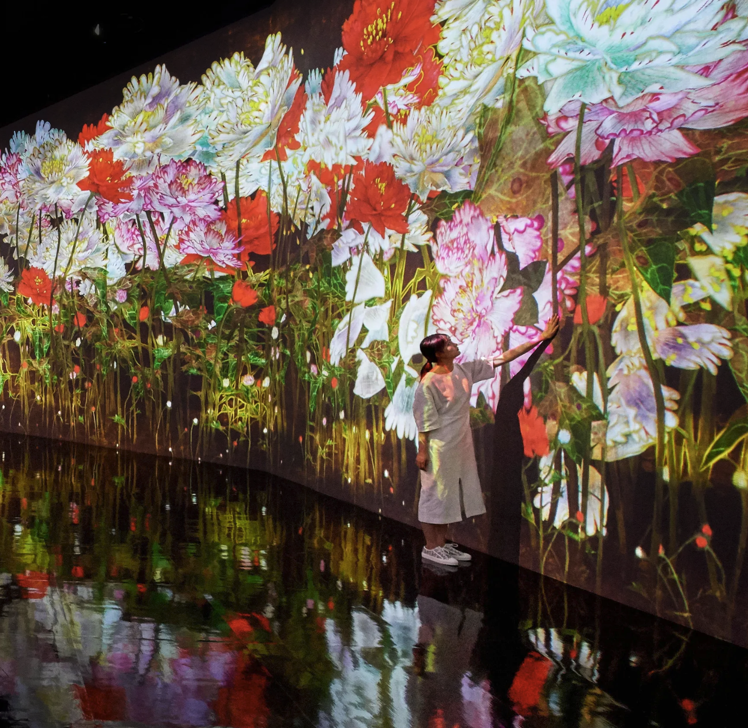

Example of floor projection artwork



